**Introduction to Display systems**

Display instruments are devices used to visually represent and communicate information about a system or process. They can be found in a variety of applications, including industrial control systems, scientific instruments, and consumer electronics.

Some common types of display instruments include:

Analog meters: These are devices that use a moving pointer or needle to indicate the value of a measured quantity on a graduated scale. Examples include analog voltmeters, ammeters, and wattmeters.

Digital displays: These use electronic components to display numeric values in a digital format. Examples include digital multimeters, LED displays, and LCD displays.

Bar graph displays: These use a series of bars to represent a range of values. They are often used to display multiple values simultaneously or to provide a quick visual indication of system performance.

Oscilloscopes: These are specialized display instruments used to visualize electrical signals over time. They can be used to diagnose problems in electronic systems or to analyze complex waveforms.

Chart recorders: These instruments use a moving pen or stylus to plot data over time on a paper chart. They are commonly used in scientific experiments and industrial processes to record data for later analysis.

Display instruments are essential tools for monitoring and controlling systems in a wide range of industries. They provide operators and technicians with critical information about system performance, allowing them to make informed decisions and take appropriate actions to maintain optimal performance.

**LED Display systems**

An LED (Light Emitting Diode) display is a type of digital display that uses an array of LED lights to display information or images. These displays are commonly found in electronic devices such as TVs, computer monitors, and mobile phones, as well as in larger displays used for advertising or information boards.

The basic construction of an LED display includes a matrix of tiny LED lights arranged in rows and columns. Each LED is made up of a semiconductor material that emits light when a current is passed through it. The LEDs are arranged in a grid pattern, with each LED representing a single pixel on the display.

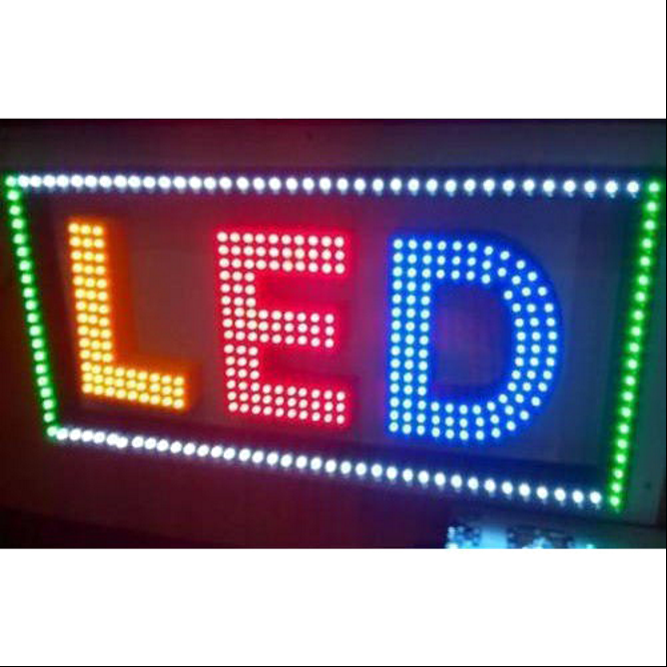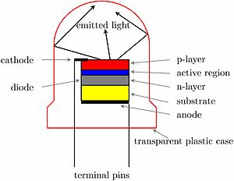

To display an image or information on the display, the controller circuit sends a series of electrical signals to the appropriate LEDs. The LEDs are turned on or off, or their brightness is adjusted, according to the signal received, resulting in the formation of the desired image or information.

LED displays can be made using either through-hole or surface mount technology. Through-hole LEDs are mounted on a circuit board with leads that are inserted into holes in the board and soldered in place. Surface mount LEDs are mounted directly onto the surface of the circuit board and soldered in place using small surface-mount components.

There are two main types of LED displays: monochrome and full-color. Monochrome displays use a single color of LED, typically red, green, or blue, to display information or images. Full-color displays use a combination of red, green, and blue LEDs to produce a wide range of colors.

LED displays are popular due to their high brightness, low power consumption, and long lifespan. They are commonly used in outdoor signage, digital billboards, and video walls, as well as in consumer electronics such as TVs and computer monitors.

**Seven Segment Display**

A seven-segment display is a type of electronic display device that can display decimal numbers, as well as a limited number of letters and symbols, using a combination of seven individually illuminated segments. Each segment can be turned on or off independently to create different numbers and characters.

The seven segments are arranged in a pattern that resembles the number "8", with an additional segment for the middle of the digit. The segments are labeled "a" through "g", with "a" being the top segment and the rest of the segments arranged clockwise from "a". The middle segment is typically labeled "dp" for decimal point.

To display a number or character on a seven-segment display, the corresponding segments are turned on or off. For example, to display the number "1", only segments "b" and "c" would be turned on. To display the letter "A", segments "a", "b", "c", "e", "f", and "g" would be turned on.

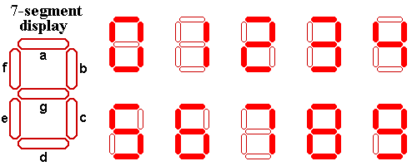Seven-segment displays can be either common anode or common cathode. In a common anode display, all the anodes of the individual LED segments are connected together, while in a common cathode display, all the cathodes are connected together. When a segment is turned on in a common anode display, a positive voltage is applied to the anode, while in a common cathode display, a negative voltage is applied to the cathode.

Each segment can be illuminated or not, depending on whether it needs to be part of the character being displayed.

To display a number or letter on a seven-segment display, you need to turn on the segments that correspond to the desired character. For example, to display the number 0, you would turn on segments a, b, c, d, e, and f, but leave segment g turned off. Here are the segment combinations for each digit and some letters:

|  |  |  |  |  |  |  |  |
| --- | --- | --- | --- | --- | --- | --- | --- |
| LED  Number | a | b | c | d | e | f | g |
| 0 | ON | ON | ON | ON | ON | ON | ON |
| 1 | ON | ON | ON | ON | ON | ON | ON |
| 2 | ON | ON | ON | ON | ON | ON | ON |
| 3 | ON | ON | ON | ON | ON | ON | ON |
| 4 | ON | ON | ON | ON | ON | ON | ON |
| 5 | ON | ON | ON | ON | ON | ON | ON |
| 6 | ON | ON | ON | ON | ON | ON | ON |
| 7 | ON | ON | ON | ON | ON | ON | ON |
| 8 | ON | ON | ON | ON | ON | ON | ON |
| 9 | ON | ON | ON | ON | ON | ON | ON |
| A | ON | ON | ON | ON | ON | ON | ON |
| B | ON | ON | ON | ON | ON | ON | ON |
| C | ON | ON | ON | ON | ON | ON | ON |
| D | ON | ON | ON | ON | ON | ON | ON |
| E | ON | ON | ON | ON | ON | ON | ON |
| F | ON | ON | ON | ON | ON | ON | ON |

Seven-segment displays are commonly used in digital clocks, calculators, and other electronic devices that display numerical information. They are also used in industrial control systems and other applications where numerical data needs to be displayed in a compact and easy-to-read format

**Common cathode Seven-segment display**

In a common cathode seven-segment display, all the cathodes of the individual LED segments are connected together and are grounded. When a segment is turned on, a negative voltage is applied to the cathode, and the corresponding anode is connected to a positive voltage source to illuminate the segment.

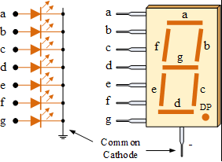

To display a number or character on a common cathode seven-segment display, the corresponding segments are turned on by applying a positive voltage to the corresponding anodes and a negative voltage to the common cathode. For example, to display the number "1", the "b" and "c" segments would be turned on by applying a positive voltage to their corresponding anodes and a negative voltage to the common cathode.

Common cathode seven-segment displays are commonly used in electronic devices such as digital clocks, calculators, and other applications where numerical data needs to be displayed. They are easy to interface with digital circuits and microcontrollers and offer a cost-effective solution for displaying numerical data

**Common anode seven-segment display**

In a common anode seven-segment display, all the anodes of the individual LED segments are connected together and are connected to a positive voltage source. When a segment is turned on, a positive voltage is applied to the anode, and the corresponding cathode is grounded to illuminate the segment.

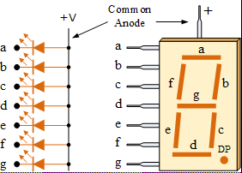To display a number or character on a common anode seven-segment display, the corresponding segments are turned on by applying a negative voltage to the corresponding cathodes and a positive voltage to the common anode. For example, to display the number "1", the "b" and "c" segments would be turned on by applying a negative voltage to their corresponding cathodes and a positive voltage to the common anode.Common anode seven-segment displays are commonly used in electronic devices such as digital clocks, calculators, and other applications where numerical data needs to be displayed. They are easy to interface with digital circuits and microcontrollers and offer a cost-effective solution for displaying numerical data.

**A Liquid Crystal Display**

A Liquid Crystal Display (LCD) is a flat-panel display technology that uses liquid crystals to create images. LCDs are commonly used in electronic devices such as televisions, computer monitors, and mobile phones.

The construction of an LCD involves several layers:

Backlight: This is a light source that provides illumination for the display. It is typically located behind the LCD panel and can be either a fluorescent or LED light source.

Rear polarizer: This is a layer of polarizing material that is placed on the back of the display. It helps to polarize the light from the backlight.

Glass substrate: This is a thin layer of glass that forms the base of the LCD. It is typically made of a transparent material such as glass or plastic.

Thin film transistor (TFT) layer: This layer consists of a matrix of transistors that control the flow of electrical current through the liquid crystals.

Color filters: These are layers of red, green, and blue filters that are placed on top of the TFT layer. They help to create the different colors that are displayed on the screen.

Liquid crystal layer: This is a layer of liquid crystals that are placed between the color filters and the TFT layer. The liquid crystals are aligned in a specific way by the electric current flowing through the transistors.

Front polarizer: This is a layer of polarizing material that is placed on the front of the display. It helps to polarize the light that passes through the liquid crystal layer and color filters.

When an electric current is applied to the transistors in the TFT layer, they control the alignment of the liquid crystals, allowing or blocking the passage of light through the color filters. By varying the amount of light that passes through each color filter, different colors and shades can be created, forming the images displayed on the screen.

LCD displays offer several advantages over other display technologies, including high resolution, low power consumption, and thin profile. They are widely used in a variety of electronic devices due to their versatility and reliability.

**Dot Matrix Display**

A dot matrix display is a type of electronic display device that can display text, graphics, and animations using a matrix of individually illuminated dots. The dots are arranged in a rectangular pattern, with each dot being controlled independently by a driver circuit.

There are two types of dot matrix displays: monochrome and color. Monochrome displays use a single color, typically red or green, while color displays use multiple colors, such as RGB (red, green, blue) or RGBW (red, green, blue, white).

The construction of a dot matrix display includes an array of LEDs or OLEDs that are arranged in a rectangular pattern. Each LED or OLED represents a single dot in the matrix. The driver circuit controls the brightness and color of each LED or OLED to create the desired display.

To display text or graphics on a dot matrix display, the driver circuit selectively illuminates the appropriate dots to create the desired image. This can be done by sending data to the driver circuit, which in turn activates the corresponding LEDs or OLEDs.

Dot matrix displays are commonly used in a variety of applications, including digital signage, electronic billboards, scoreboards, and outdoor advertising. They offer a high level of flexibility in terms of displaying custom content and are often used for dynamic messaging and advertising. However, they may have limited resolution and color depth compared to other display technologies.

**16x2 LCD Module**

The 16x2 LCD module is a commonly used alphanumeric display module that can display up to 16 characters per line and has 2 lines. It is based on the Liquid Crystal Display (LCD) technology and is commonly used in electronic devices such as calculators, digital clocks, and other applications where numerical and textual data needs to be displayed.

The construction of a 16x2 LCD module includes a liquid crystal display panel that is divided into two rows of 16 characters each. The module also includes a controller that communicates with the host microcontroller and provides the necessary signals to control the LCD panel. The controller chip is usually an HD44780 or a compatible chip.

The module has a standard 16-pin interface, which includes power and signal pins. The pins are used to supply power to the module and to control the LCD display. The module can be interfaced with a microcontroller using a 4-bit or 8-bit parallel interface or a serial interface.

To display text on the 16x2 LCD module, the host microcontroller sends ASCII codes to the controller chip, which in turn generates the necessary signals to display the characters on the LCD panel. The module also supports custom character generation, which allows users to create their own characters and display them on the LCD panel.

The 16x2 LCD module is widely used in electronic projects, and there are many libraries and code examples available for interfacing with popular microcontroller platforms such as Arduino, Raspberry Pi, and STM32. It is a cost-effective and versatile display solution for displaying textual information in a variety of applications.

**Pin configuration 16x2 display module**

The 16x2 LCD module has a standard 16-pin interface, with each pin serving a specific function. Here is the pin configuration of the 16x2 LCD module:

VSS: Ground pin

VDD: Power supply pin (+5V)

VO: Contrast adjustment pin

RS: Register select pin (RS=0 for instruction register, RS=1 for data register)

RW: Read/write pin (RW=0 for write, RW=1 for read)

E: Enable pin

D0: Data pin 0 (not used in 4-bit mode)

D1: Data pin 1 (not used in 4-bit mode)

D2: Data pin 2 (not used in 4-bit mode)

D3: Data pin 3 (not used in 4-bit mode)

D4: Data pin 4

D5: Data pin 5

D6: Data pin 6

D7: Data pin 7

A: Backlight anode (+)

K: Backlight cathode (-)

Note that pins 7-14 are used for data transmission in 8-bit mode, while pins 11-14 are used in 4-bit mode. The contrast adjustment pin (VO) is used to adjust the contrast of the display by varying the voltage applied to it. The backlight pins (A and K) are used to control the backlight of the LCD module.

It is important to note that the pin configuration of the 16x2 LCD module may vary slightly depending on the manufacturer and the specific model.

**Differences between LCD and LED**

LCD (Liquid Crystal Display) and LED (Light Emitting Diode) displays are two commonly used types of electronic display technologies, with several differences between them:

Technology: LCD displays use liquid crystals to block or pass light to create an image, while LED displays use an array of light-emitting diodes to emit light and create an image.

Power Consumption: LED displays generally have lower power consumption than LCD displays, which can be attributed to the fact that LEDs use less power to produce the same level of brightness as an LCD.

Brightness and Contrast: LED displays generally have higher brightness and contrast ratios than LCD displays, making them ideal for outdoor use and environments with high ambient light levels.

Color Reproduction: LED displays can reproduce a wider range of colors than LCD displays, making them suitable for applications where color accuracy is important.

Viewing Angle: LED displays have a wider viewing angle than LCD displays, which means that the image quality is maintained even when viewed from an angle.

Cost: LCD displays are generally less expensive than LED displays, particularly for smaller sizes.

Resolution: Both technologies can achieve high resolutions, but LED displays generally have a higher pixel density than LCD displays.

Overall, the choice between LCD and LED displays will depend on the specific application and requirements, with factors such as power consumption, brightness, color accuracy, and cost being important considerations.

What does LED stand for?

a. Low Energy Diode

b. Light Emitting Diode

c. Laser Emitting Diode

d. Lithium Emitting Diode

Answer: b. Light Emitting Diode

Which color commonly used for outdoor LED displays?

a. Red

b. Green

c. Blue

d. White

Answer: a. Red

What is the purpose of a LED driver in a display system?

a. To convert the AC power supply to DC

b. To regulate the brightness of the LED display

c. To control the temperature of the LED display

d. To transmit data to the LED display

Answer: b. To regulate the brightness of the LED display

Which type of LED display has the highest resolution?

a. DIP

b. SMD

c. COB

d. MCOB

Answer: b. SMD

Which type of LED display is the most energy-efficient?

a. DIP

b. SMD

c. COB

d. MCOB

Answer: b. SMD

What is the main disadvantage of a passive matrix LED display?

a. Low refresh rate

b. Low contrast ratio

c. Low brightness

d. High power consumption

Answer: a. Low refresh rate

What is the main advantage of an active matrix LED display?

a. High refresh rate

b. High contrast ratio

c. High brightness

d. Low power consumption

Answer: a. High refresh rate

Which type of LED display is commonly used for outdoor advertising?

a. Fixed display

b. Rental display

c. Mobile display

d. Transparent display

Answer: a. Fixed display

Which type of LED display is commonly used for stage events?

a. Fixed display

b. Rental display

c. Mobile display

d. Transparent display

Answer: b. Rental display

Which type of LED display allows for transparency while displaying content?

a. Fixed display

b. Rental display

c. Mobile display

d. Transparent display

Answer: d. Transparent display

What is a seven-segment display?

a. A type of LED display with seven segments

b. A type of LCD display with seven segments

c. A type of OLED display with seven segments

d. A type of plasma display with seven segments

Answer: a. A type of LED display with seven segments

How many segments does a seven-segment display have?

a. 5

b. 6

c. 7

d. 8

Answer: c. 7

Which of the following is NOT a typical use of a seven-segment display?

a. Displaying time on a digital clock

b. Displaying temperature on a thermostat

c. Displaying speed on a speedometer

d. Displaying images on a digital photo frame

Answer: d. Displaying images on a digital photo frame

Which of the following is NOT a common type of seven-segment display?

a. Common anode

b. Common cathode

c. Common ground

d. Common positive

Answer: c. Common ground

What is the purpose of a decoder in a seven-segment display system?

a. To convert binary data into a format that can be displayed on the display

b. To regulate the brightness of the display

c. To control the temperature of the display

d. To transmit data to the display

Answer: a. To convert binary data into a format that can be displayed on the display

Which of the following is the most common type of seven-segment display?

a. Common anode

b. Common cathode

c. Common ground

d. Common positive

Answer: b. Common cathode

What is the advantage of using a multiplexing technique in a seven-segment display system?

a. It reduces the number of wires needed to connect the display

b. It increases the brightness of the display

c. It improves the resolution of the display

d. It reduces the power consumption of the display

Answer: a. It reduces the number of wires needed to connect the display

What is the disadvantage of using a multiplexing technique in a seven-segment display system? a. It reduces the brightness of the display

b. It increases the number of wires needed to connect the display

c. It decreases the refresh rate of the display

d. It increases the power consumption of the display

Answer: a. It reduces the brightness of the display

Which of the following is an alternative to a seven-segment display for displaying numerical information?

a. Dot matrix display

b. LCD display

c. OLED display

d. Plasma display

Answer: a. Dot matrix display

Which of the following is a limitation of a seven-segment display?

a. It can only display numerical information

b. It is not visible in bright sunlight

c. It has a low resolution

d. It is not compatible with digital circuits

Answer: a. It can only display numerical information

Which type of seven-segment display is easier to read from a distance?

a. Common anode

b. Common cathode

c. Both are equally readable

d. It depends on the specific display

Answer: a. Common anode

Which type of seven-segment display is easier to interface with a microcontroller?

a. Common anode

b. Common cathode

c. Both are equally easy to interface

d. It depends on the specific microcontroller

Answer: b. Common cathode

How many pins does a typical seven-segment display have?

a. 5

b. 7

c. 9

d. 11

Answer: b. 7

Which material is commonly used to make the segments of a seven-segment display light up?

a. Glass

b. Plastic

c. Metal

d. Silicon

Answer: b. Plastic

Which type of seven-segment display is more energy-efficient?

a. Common anode

b. Common cathode

c. Both consume the same amount of energy

d. It depends on the specific display

Answer: b. Common cathode

How many different patterns can be displayed on a seven-segment display?

a. 7

b. 16

c. 64

d. 128

Answer: b. 16

Which type of seven-segment display is more common?

a. Common anode

b. Common cathode

c. Both are equally common

d. It depends on the specific application

Answer: b. Common cathode

What is the purpose of a decoder in a seven-segment display system?

a. To convert binary data to seven-segment format

b. To regulate the brightness of the seven-segment display

c. To control the temperature of the seven-segment display

d. To transmit data to the seven-segment display

Answer: a. To convert binary data to seven-segment format